A000-AM,C-Taino-Amulet-anthropogenic figure-Hallucinogenic trance state

This contorted figure must have originated in a hallucinogenic trance. Hands curve back over head with knees tightly drawn. It is made from fossil coral. The hole seen on the side of pendant figure 4 is a natural imperfection. It measures 8.5cm or 3.3". Originally from the Dominican Republic. Dating c1000-1500AD.

Case no. 18

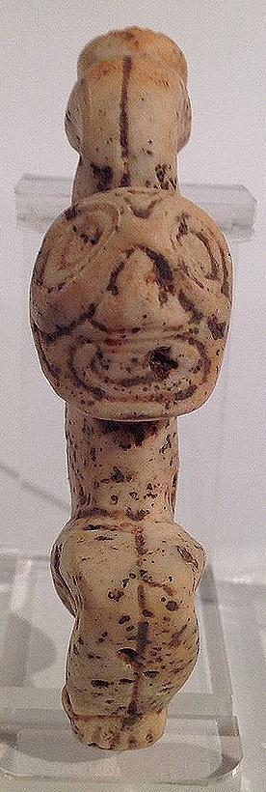 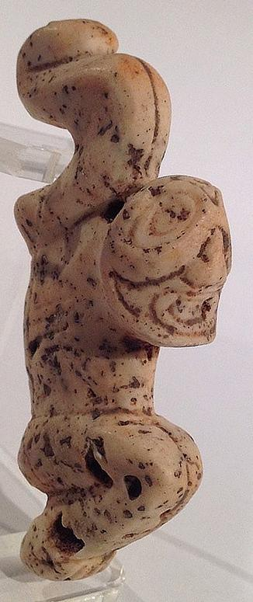 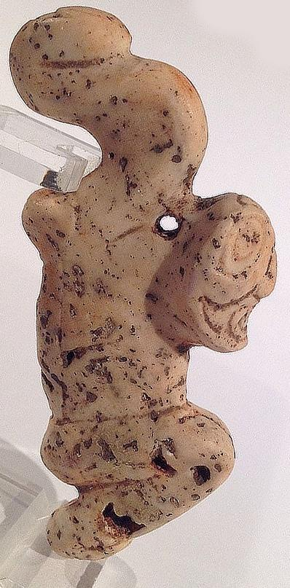

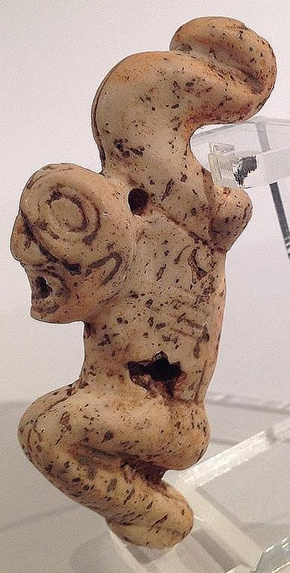 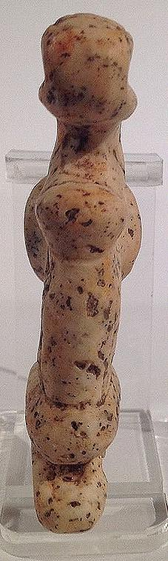

# Order details

## Sales order

Sold by [flapast](http://myworld.ebay.com/flapast) ( [13303](http://feedback.ebay.com/ws/eBayISAPI.dll?ViewFeedback&userid=flapast) )

### Delivery package 1 of 1

Estimated delivery Saturday, Jan 9, 2016

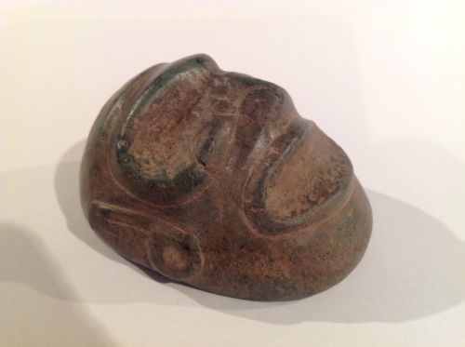

#### [Taino Stone Ancestral Head, Pre Columbian](http://www.ebay.com/itm/262204237732)

|  |  |
| --- | --- |
| Item price | $162.50 |
| Quantity | 1 |
| Item number | 262204237732 |
| Shipping service | USPS Priority Mail |

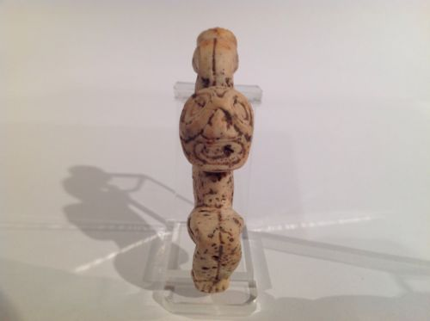

#### [Taino Stone Spirit Being, Pre Columbian](http://www.ebay.com/itm/262204292205)

|  |  |
| --- | --- |
| Item price | $76.00 |
| Quantity | 1 |
| Item number | 262204292205 |
| Shipping service | USPS Priority Mail |